

automatic irrigation system

Name:saleh ahmed alheeh

ID:201614721

Problem:

The owner of a farm is complaining about the poor production of the farm and the difference of some of the needs of some plants for water and the difficulty of regularity of a specific time for irrigation and access to some problems and knowledge of places where there is a problem and solve the problem of waste water and facilitate supervision of the owner of the farm

Interviewing

* Name: Mohammed
* Job : Pharmacist
* Title / Role: farm owner
* What tasks are you responsible for completing?

Interested in completing irrigation Production and maintenance

Provides the required tools

* What problems prevent you from performing your duties?

Shortage of time

Farm area is big

The farm is far from the city

Lack of employment

* What problems do you encounter while supervising the farm? Is there a standard way to solve it, or do you have an alternative solution?

Water leakage problem

Different irrigation time

Some plants have special water needs

* Why is this a problem?

Because it affects production of the farm

* How would you ideally like to solve the problem?

Reduce waste of resources

Increase farm productivity

* What else is a problem for you?

Difficulty in finding the problem for maintenance

* Are there other things that give you trouble?

High water bill

* Who will be the users of the system?

Farmers and maintenance worker

* What level of education or training do the users have?

Satisfied

* What computer skills do the users have?

Basic skills

* Are users familiar with this type of IT system?

No

* What technical platforms do they use today?

Smart phones

* What are your expectations regarding system usability?

Solve most problems and ease of use

* What training needs do you expect for the system?

Teaching basic things

* What kind of documentation do you expect?

Hard copy

* What are the things you want to have in the system?

Water pumping level

Information about water waste

* What are your expectations for system performance?

Fast performance

* What is the level of security?

Weak security

* Can you think of any additional requirements that we should know about?

High efficiency

* Are there any other problems you’re experiencing? If so, what are they?

No

* Are there any other questions you think I should be asking, or anything else you want to tell me?

No

* Can I contact you again if I need to ask some follow-up questions?

Yes

* Would you want to participate in a review of the requirements later on?

Yes

Requirements:

Special time allocation for irrigation and pumping level

Locating fault locations

Information about water spend

Remote control by smart devices

Fast

High efficiency

The security level is poor

Easy to use

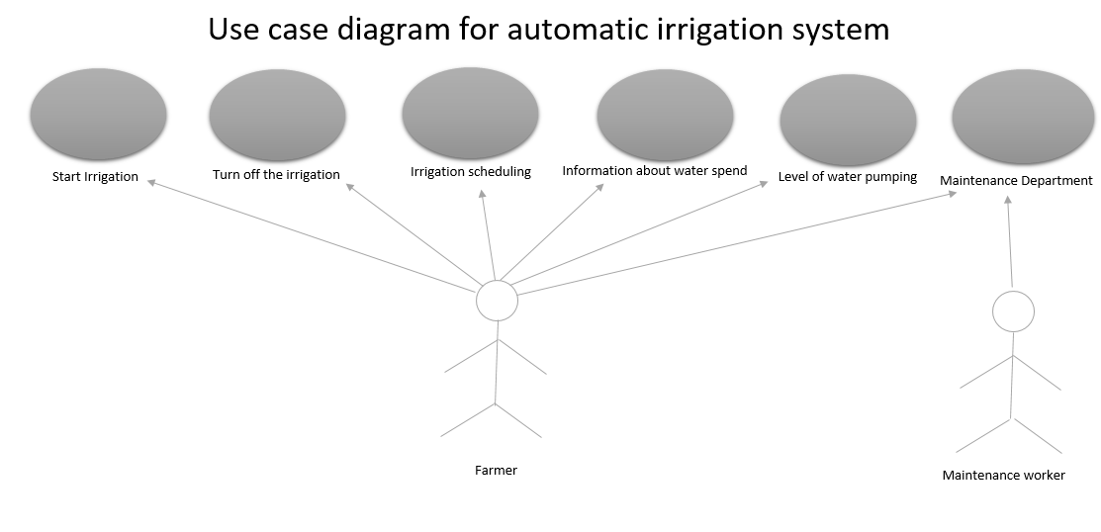

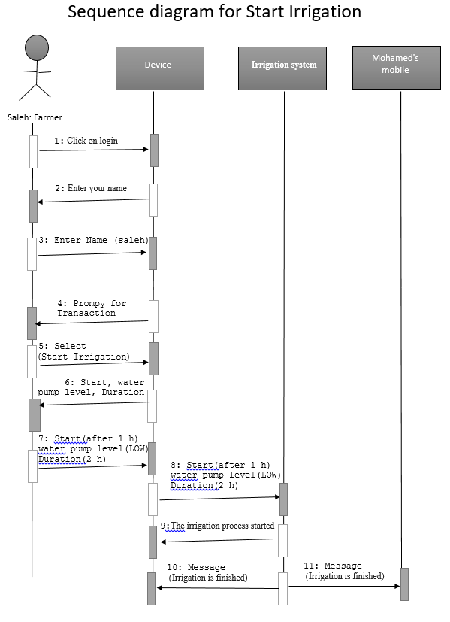

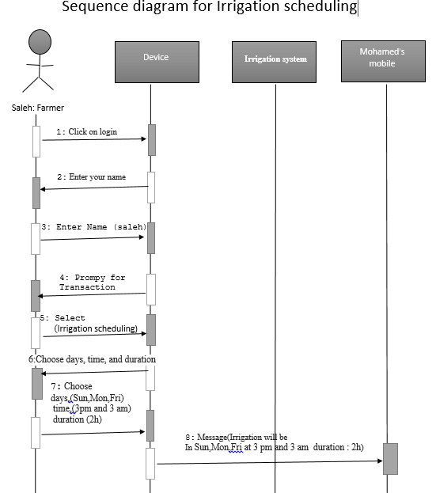

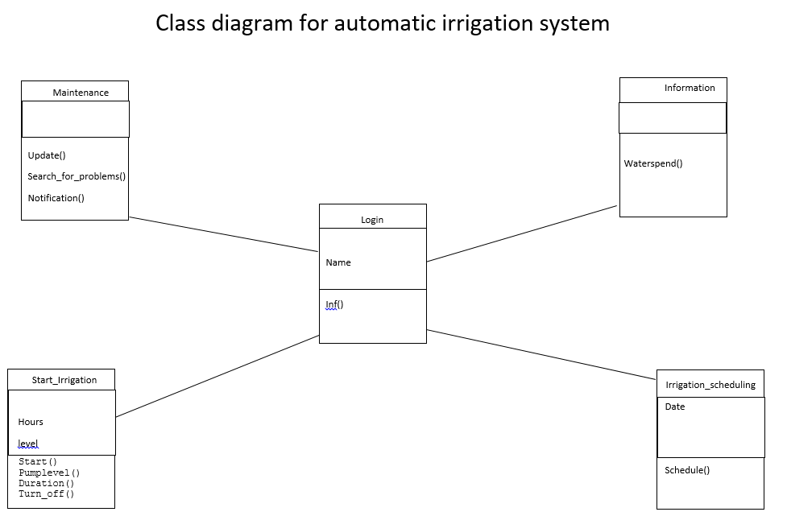

What do you expect from your system to do?

It is easy for the owner of the farm, the farmers and the maintenance worker. The owner of the farm can know some of the important tasks of the farm and facilitate the farmer's irrigation control process and make it easier for the maintenance worker to locate the problem

What did you learn from your project outputs?

I learned this project about the skill of interviewing non-functional requirements and learned about the benefits of diagram